WEEK 1

1. Implement Tic –Tac –Toe Game
import random

def display_board(board):
print("\n")
print(" " + board[0] + " | " + board[1] + " | " + board[2])
print("---+---+---")
print(" " + board[3] + " | " + board[4] + " | " + board[5])
print("---+---+---")
print(" " + board[6] + " | " + board[7] + " | " + board[8])
print("\n")

def check_winner(board, player):
winning_combinations = [
(0, 1, 2), (3, 4, 5), (6, 7, 8),
(0, 3, 6), (1, 4, 7), (2, 5, 8), (0, 4, 8),3 (2, 4, 6)
]

for combination in winning_combinations:
if all(board[i] == player for i in combination):
return True

return False

def check_draw(board):
return all(cell != " " for cell in board)

def computer_move(board):
empty_cells = [i for i in range(9) if board[i] == " "]

if empty_cells:
return random.choice(empty_cells)

def play_game():
board = [" "] * 9

human = "X"
computer = "O"

print("===== TIC-TAC-TOE =====")
print("You are X and the computer is O.")
print("Choose a position from 1 to 9.")

print("\nBoard positions:")
print(" 1 | 2 | 3")
print("---+---+---")
print(" 4 | 5 | 6")
print("---+---+---")
print(" 7 | 8 | 9")

turn = random.choice(["human", "computer"])

while True:
display_board(board)

if turn == "human":
while True:
try:
position = int(input("Enter your position (1-9): "))

if position < 1 or position > 9:
print("Please enter a number between 1 and 9.")
elif board[position - 1] != " ":
print("That position is already occupied.")
else:
board[position - 1] = human
break

except ValueError:
print("Please enter a valid number.")

if check_winner(board, human):
display_board(board)
print("Congratulations! You won!")
break

if check_draw(board):
display_board(board)
print("The game is a draw!")
break

turn = "computer"

else:
print("Computer is making a move...")
position = computer_move(board)
board[position] = computer

if check_winner(board, computer):
display_board(board)
print("Computer wins!")
break

if check_draw(board):
display_board(board)
print("The game is a draw!")
break

turn = "human"

play_game()

OUTPUT:
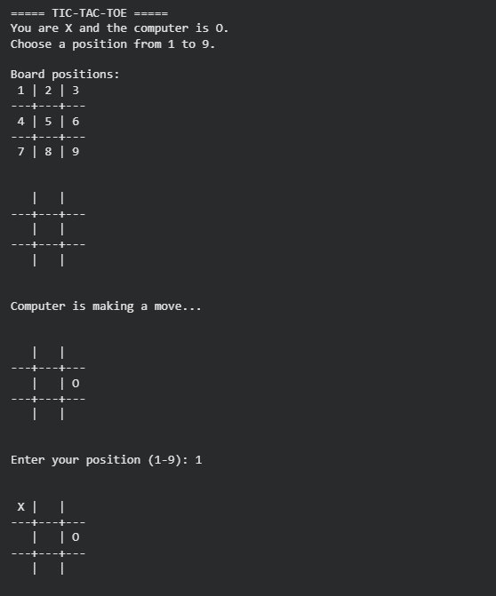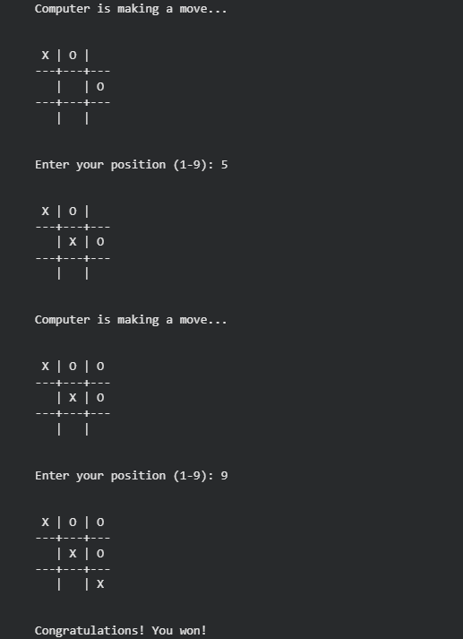

2. Implement vacuum cleaner agent
simple reflex agent

def simple_reflex_agent(location, status):
if status == "Dirty":
return "Suck"
elif location == "A":
return "Move Right"
elif location == "B":
return "Move Left"

location = "A"
room_A = "Dirty"
room_B = "Dirty"

print("Initial State:")
print("Room A:", room_A)
print("Room B:", room_B)
print("Vacuum Location:", location)

while room_A == "Dirty" or room_B == "Dirty":

if location == "A":
action = simple_reflex_agent(location, room_A)

if action == "Suck":
room_A = "Clean"
print("Action: Suck -> Room A cleaned")
else:
location = "B"
print("Action: Move Right -> Vacuum moved to Room B")

elif location == "B":
action = simple_reflex_agent(location, room_B)

if action == "Suck":
room_B = "Clean"
print("Action: Suck -> Room B cleaned")
else:
location = "A"
print("Action: Move Left -> Vacuum moved to Room A")

print("\nFinal State:")
print("Room A:", room_A)
print("Room B:", room_B)
print("Vacuum Location:", location)
print("Goal Achieved: Both rooms are clean!")
OUTPUT:
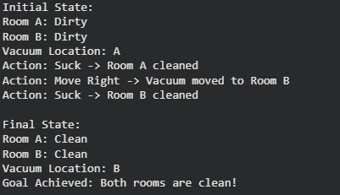

GOAL BASED AGENT

class VacuumCleaner:
def __init__(self, location, room_A, room_B):
self.location = location
self.room_A = room_A
self.room_B = room_B

def goal_achieved(self):
return self.room_A == "Clean" and self.room_B == "Clean"

def act(self):
if self.location == "A":
if self.room_A == "Dirty":
self.room_A = "Clean"
print("Action: Suck -> Cleaned Room A")
else:
self.location = "B"
print("Action: Move Right -> Moved to Room B")

elif self.location == "B":
if self.room_B == "Dirty":
self.room_B = "Clean"
print("Action: Suck -> Cleaned Room B")
else:
self.location = "A"
print("Action: Move Left -> Moved to Room A")

def display(self):
print("\nCurrent State:")
print("Room A:", self.room_A)
print("Room B:", self.room_B)
print("Vacuum Location:", self.location)

vacuum = VacuumCleaner("A", "Dirty", "Dirty")

vacuum.display()

while not vacuum.goal_achieved():
vacuum.act()
vacuum.display()

print("\nGoal State Reached!")
print("Both rooms are clean and dust-free.")

OUTPUT:
